# Fitness Tracking System

# Thant Pyae Sone Htoo 001474036

# Supervisor: Francis Murphy

# Initial Contextual Report

# COMP1682 Final Year Project

# BSc Computing

# Due Date:

# Word Count:

# Abstract

# Table of Contents

# Introduction

## Background

### History

Founded in 2023 by a fitness trainer, Nway Yoon Mann and her brother, **CoreFitness** is a health club situated on Ma Hlwa Kone Street in Tamwe Township, Myanmar. The fitness center was established with the aim of improving public health and fitness. The founders are focusing on expanding the reach at the present.

### Problem Domain

At the present, the fitness center relies on a **manual process**, people have to register a membership in-person. Clients have to physically enter the gym and interact with the trainers for tailored workout routines. Trainers also have to track their clients’ progress manually. People who live across the cities cannot be in the gym physically and those who are busy will not be able to come to the center. Therefore, the purpose is to provide those people with workouts that will require no equipment.

### Field of Project

The current manual system will be converted into computerized web-based system. In the system, all of the users have to register to enter the website and the default role will be member role. There will be three (3) sections in this system. The first section is the **member registration** and the second section will be **workouts and routines library**. In the second one, there will be workouts and routines that are created by the admin and the trainers. The users can access both of them. Besides, users can create their own customized routines based on their weak points of their bodies. Each workout and routine will be having description. The last section is that there will be a **progress tracking function** for each user in order to track the progress weekly or monthly.

# Aims and Objectives

## Aims

* To **convert** the manual system into smart fitness tracking system where users can register online and access the workouts and routines.
* To **assign** the personal trainers to members. To access via website, helping the members to exercise remotely.
* To **provide** the systematic workouts and routine libraries which can be remotely accessible by the members.
* To be able to **create** tailored routines based on the members’ weak points.

## Objectives

### 1. Research

In this section, investigating the process of the current manual fitness system is done in order to identify the current issues and challenges. This is done by using interview method in order to obtain the qualitative and detailed data. Moving forward, other online fitness tracking systems are researched and investigated to understand how they are processing their functions and other features. Then, the technical aspects of computerized systems are researched how the manual system can transform into online fitness tracking system and deciding the system will be web-based or software. Moreover, topics that are related to fitness tracking are researched such as type of methodology that will be best suited for the system, currently trending technology in the fitness industry and appropriate database and research on legal, social, ethical and professional issues.

### 2. Planning

The planning phase covers the scope of the project that defines the functions of the system. The detailed outlines of the project plan are designed, defining timeboxes, MoSCoW prioritization and deliverables, for instance. Moreover, similar fitness tracking websites are researched in order to gain insights and inspirations that are helpful when designing and developing the system.

### 3. Analysis

In the analysis phase, the requirements of the system are analyzed both in business and technical aspects. Following, both high-level functional, low-level functional requirements and non-functional requirements are analyzed. High-level functional requirements are helpful in building the system’s core functions. The rest help with the system software’s usability and user experience goals such as the performance of the system and security of the system.

### 4. Design

During the design phase, selecting and preparing the best software and tools for client side, server side and prototypes are done first, which are, Visual Studio Code, Programming languages and Figma, for example. Moreover, class diagrams and use cases are created to visualize the structure of the system. Besides, wireframes and prototypes are built to identify the user interface before diving into the developing process. Finally, after verifying the class diagram, database design and data dictionaries will be created before starting the coding process so that users can have clear visual of how data works in the fitness tracking system.

### 5. Development

In this phase, database tables are created by using PostgreSQL and Prisma ORM. By writing TypeScript codes in Prisma, it automatically creates the PostgreSQL tables which is absolutely efficient. Then, static web pages will be written with React JS using Tailwind CSS and ShadCN UI library. Furthermore, backend API will be generated using another JavaScript framework, Node Js with Express JS. Finally, both frontend and backend will be integrated to have a dynamic fitness tracking web app.

### 6. Testing

After developing the software, it will be tested before deploying. Firstly, the system will undergo functional testing which consists of unit testing, integration testing, black-box testing and white-box testing, to ensure that all of the core functions are performing effectively as planned. The system will be evaluated to verify that it meets the users’ needs and if there are any issues or problem, it has to be fixed immediately so that it can improve the user experience.

### 7. Evaluation & Conclusion

This is the final stage of the process and in this phase, the variety of evaluations are made. The first one is to evaluate the real project’s outcome against the initial aims and objectives, which aims and objectives are achieved and which are left out. Then, evaluation against the similar systems are made in order to identify the what kind of differences are made and what make the website more valuable and more effective. Moreover, strengths and weakness are also accessed to determine which part of the system needs to be fixed and which areas have potential for future enhancements. Finally, summarize the entire project, emphasizing on conclusion, justifications and recommendations for future amendments.

# Approach

## Research Method

**DSDM** is an agile framework project management method that is the enhancement of Rapid Application Development (RAD) (Do, 2025). It mainly focuses on the collaboration, iterative method and delivering the functional requirements to the end-user within the timebox range (Do, 2025). It focuses on 8 main principle, namely, focus on the business need, deliver on time, collaborative, never compromise quality, build incrementally from firm foundations, develop iteratively, communication continuously and clearly and demonstrate control (Do, 2025). Each fact ensures the product is delivered on time with the best quality and user involvement. Moreover, DSDM emphasizes on timeboxes such as analysis, development and review. It also defines MoSCoW prioritization based on the functional requirements and non-functional requirements. Moreover, DSDM is flexible so that it can easily adapt to both economic and technical environments.

**SSADM** is a computer application development method that applies waterfall method and focuses on dividing the process into chapters, and sequential phases based on logical and physical design (Lutkevich, 2022). SSADM follows 5 stages in its development, namely, feasibility study, requirement analysis, defining the requirements, logical system specification and physical system designs (Lutkevich, 2022). Instead of timeboxes and MoSCoW prioritizations, SSADM uses modelling methods such as logical data models (ER diagrams) and data flow diagrams. It is better for fixed requirements, and clear documentation.

## Research method justification

**DSDM Atern methodology** has been selected to implement in the development of CoreFitness System because of its strong features such as timeboxing, collaboration and quick deliverables of software (Lucid, 2025).

First of all, DSDM uses timeboxes which can enhance the developer’s focuses and productivity. Timeboxes ensure that the defined tasks and functions are developed within the limited time range so that the features can be delivered on time. This helps reduce the risk of project delays.

Secondly, DSDM focuses on delivering the business needs. Therefore, the system can deliver the value of the business but not just the fancy website. In the CoreFitness, the system should focus more on solving the user’s health problems such as keep tracking of the member’s gym progress, and creating routines for the members.

Thirdly, DSDM allows the users to interact with the developers often. Therefore, users can have knowledge of how the development is going and clients can give feedback to the team so that they can fix before it is too late. In the CoreFitness system, the team can ask the gym admin to review the website and fix the parts where the admin disapprove of.

Based on these facts, **DSDM Atern methodology** is the most suitable for the development of the CoreFitness system because of its delivering on time, focusing on the business need and collaborative feature. DSDM also makes sure that the system not only meet the technical standards but also have genuine interaction with stakeholders through iterative development. Since DSDM can easily adapt to changes and receive feedbacks from the clients, it is certain that this is the best approach to this fitness system development.

# Literature Review

## Tools and Languages

### Technologies

There are many languages for writing web applications. **PHP with Laravel**, one of the most popular frameworks, is a strong language for large scale projects which is easy to host and has many built-in features (FASTFWD, 2025). Secondly, **Java** is also enterprise level language which is also used for large scale systems. It can be used with a framework called Spring Boot which have is java web-based and has built-in features such as dependency injections and rapid database integration (Jayeshwarke, 2023). Although, it is complicated to set up, Java Spring Boot has high performance and sturdy security. Finally, using **JavaScript** is very efficient since it can support both backend (NodeJS) and frontend (ReactJS). ReactJS is a robust JavaScript library which is fast, simple and used for interactive UIs (RisingStack, 2024). On the other hand, NodeJS is the server-side run time environment that can handles numerous API requests effectively. Besides, using ExpressJS can make it easier write the backend codes.

#### Technology justification

**JavaScript** frameworks and libraries, ReactJS, NodeJS and ExpressJS are used for this fitness tracking project since it is a dynamic web application that will contain both user-interface and backend APIs.

**ReactJS** is chosen to be used as a frontend tool because of it speed because React is component-based and they are reusable so the developer does not have create duplicated elements repeatedly. Moreover, whenever the website reloads, it does not reload the backend server and only reloads inside the browser so that its speed is immeasurable (Modan, 2025). Moreover, there are many components libraries that can be used with ReactJS so that developers do not have to write all of the components from the scratch. This fact alone tops the ReactJS off the chart.

**NodeJS** will be used as the backend tool because it can easily build a scalable web app (Sharma, 2025). NodeJS is the easy-to-learn runtime environment and can create RESTful API with ease, not like the other programming languages. ExpressJS is also a lightweight and easy to learn NodeJS framework that can build backend servers for web applications (TEAM, 2025). It also supports middleware which can performs variety of tasks such as authentication and handling errors (TEAM, 2025). Besides ExpressJS provides a robust routing system so that the web app can easily handle the HTTP requests for various URLs (TEAM, 2025).

### Databases

There are also many types of databases, MySQL, MongoDB, Microsoft SQL Server, PostgreSQL. Even though, **MySQL** does not support advance features compared to PostgreSQL, it is a reliable database that is used in many projects. **MongoDB** is the easy-to-go NOSQL database which has flexible schemas. **Microsoft** **SQL** Server is also an enterprise-level database with tight security. **PostgreSQL** is one of the robust and open-source databases that have variety of data-types, can define their own complex types and robust (Ellingwood, 2025).

#### Database Justification

**PostgreSQL** is the database tool for the fitness tracking project. Using PostgreSQL is cost effective since it is an open-source software and developers do not have to purchase license (Quest, 2025). Since it is a relational database, it is best suited for the fitness tracking website. It also supports advanced features such as generating reports using complex queries, outputting how much calories burned in a month, for instance.

### Prototyping tools and justification

For the prototyping tools, there are many tools such as Figma, Adobe XD and Axure RP. **Figma** is one of the most used UI/UX tools that have many efficient features. For example, Figma components are very useful features which are reusable. Since it is cloud-based, files can be accessed through devices (oui-flow, 2025). Moreover, it has various plug-ins and developer tools which can generate HTML codes which is very efficient. On the other hand, many people used **Adobe** **XD**. It is light-weight because the components are vector-based and allows sharing and collaboration as in Figma (David Ephraim, ATAK Interactive President, Development + Operations, 2024). Lastly, **Axure** **RP** is also a prototyping software which is not only easy and fast prototyping but also provide collaborative and user testing such as usability testing (AxureBoutique, 2023). Moreover, when connecting each page for interactive designs, it is more efficient than in Figma.

**Figma** is chosen for the prototyping tool for my project. First of all, students can apply for educational plan and can start designing for their projects. It can run in browsers so that users do not have to separately install the desktop software. Since the storage is cloud-based users can access the files from anywhere with any devices. Moreover, Figma also have multiple plugins, for example, we don’t have to download the icon image from the browsers but can import with Figma plugins. Lastly, it can create components so that we don’t have to create the elements repeatedly which can waste your time. That is why, Figma will be used as a prototyping tool for this project.

# Product Research

## Comparing of similar products or platforms against a set of criteria for Usability purpose

I am going to compare two fitness tracking system that have the similar logic and structure as my project. They are Hevy and GymWolf which are web-based fitness tracking system.

Hevy is the modernized fitness tracking system that can be used in both websites and mobiles which helps people with their fitness journey. It is one of the famous fitness software that is known for its minimal and clean UI designs, having user freedom which means each user can freely create their own routines and workouts. They system also allows the users to track their fitness journey by tracking sets and reps, weights and rest times. The system also offers community features so that users can connect with each other who share the same goal. (Hevy, 2025)

GymWolf is also another web-based fitness tracking system which aids users in logging their workouts and keep tracking of the user’s progress. It also allows the users to create their own customized workout plans and performance statics. The system allows both the amateurs and advanced members by providing well organized workout routines and detailed analytics documentations. (GymWolf, 2025)

## Usability based on user interface

### GymWolf

#### Visibility of system status

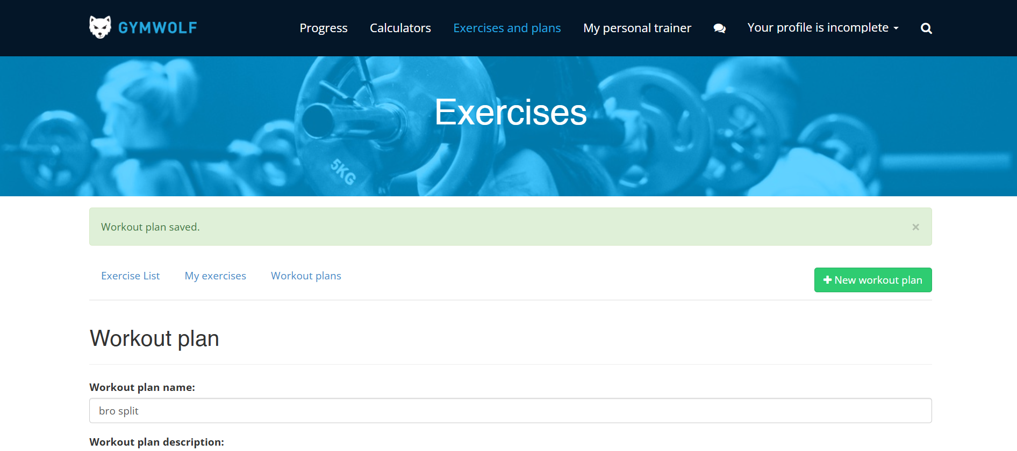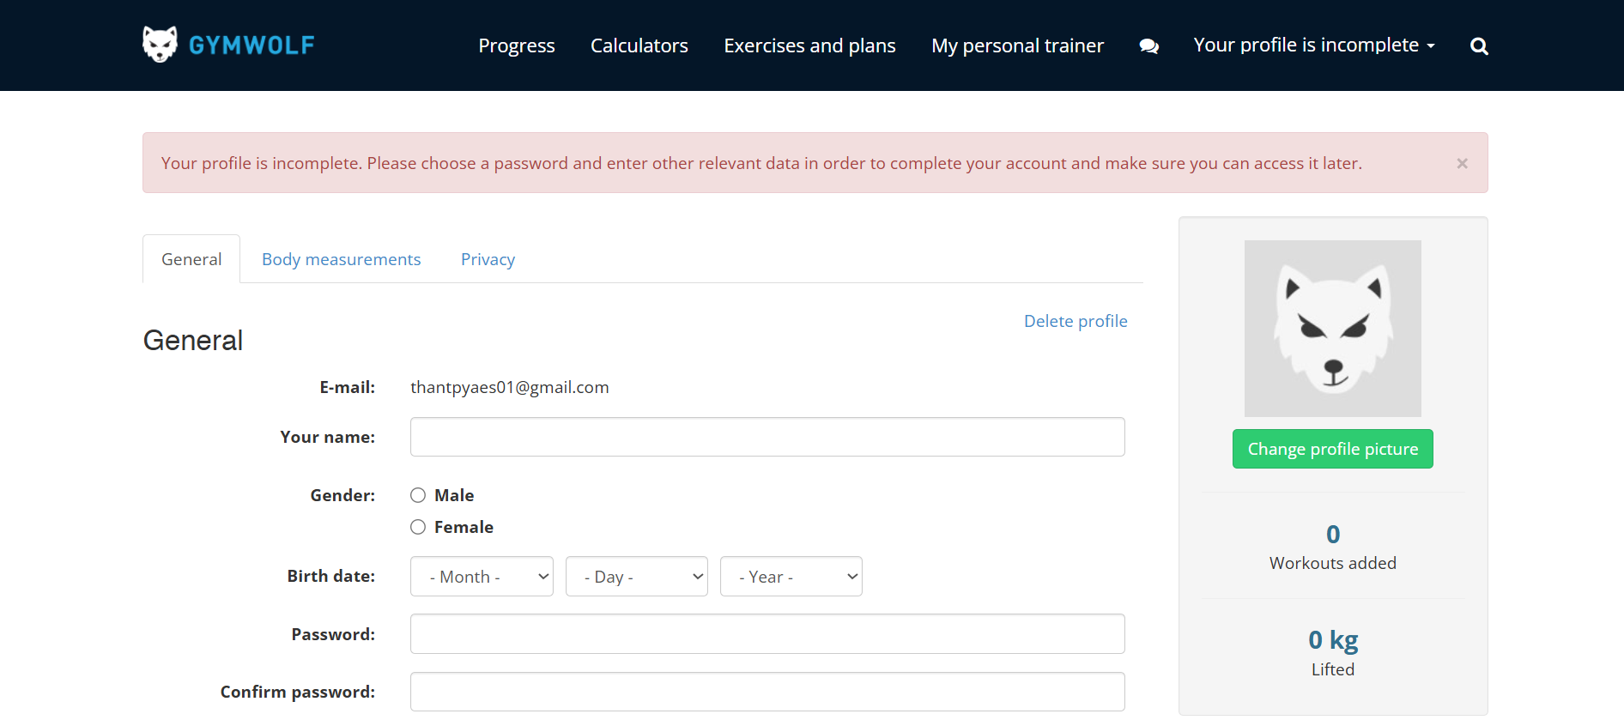

The system also shows that the status whether it is correct or incorrect. For example, in the first image, after creating the new workout plan, it shows the success message with green background. This let the users know their actions have finished without any errors. Also, in the second figure, the user didn’t update any of their personal information. Therefore, the system shows the error message that the personal information are not filled yet.

#### Match between system and the real world

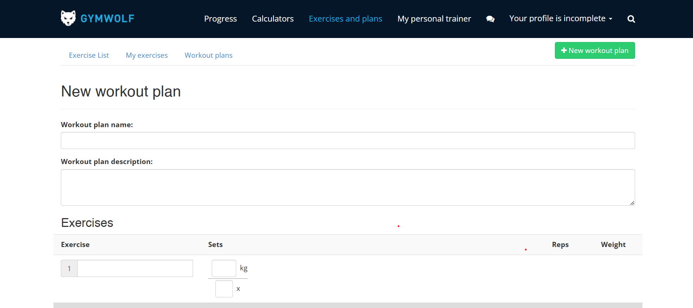

When creating the workout plans, workout names, sets and reps are required. Users are familiar with these terms since they have been using in the fitness industry. By using these gym-related terms, it helps users not to confuse and feels familiar with the website.

#### User control and freedom



User have absolute control within the website. For example, unlike other fitness website, the system allows the user to create new workouts and new routine plans so that users can customized the routine plans that aligns with their weakness. Moreover, as shown in the figure above, users can also edit their personal information.

#### Help users recognize, diagnose and recover from errors

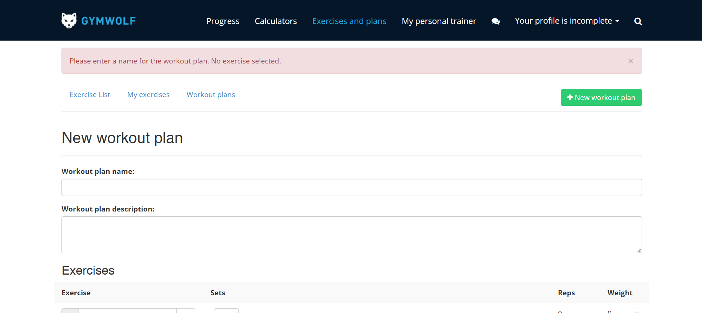

When creating a workout plan, the user has to input the required information in order to create. In the image provided above, the user does not type in the workout plan name and do not choose the workouts so that the system shows the error that the new plan needs to have a name and includes workouts. By doing this, users know which kind of error they have done and what are they missing and they can later fill them in.

#### Error Prevention

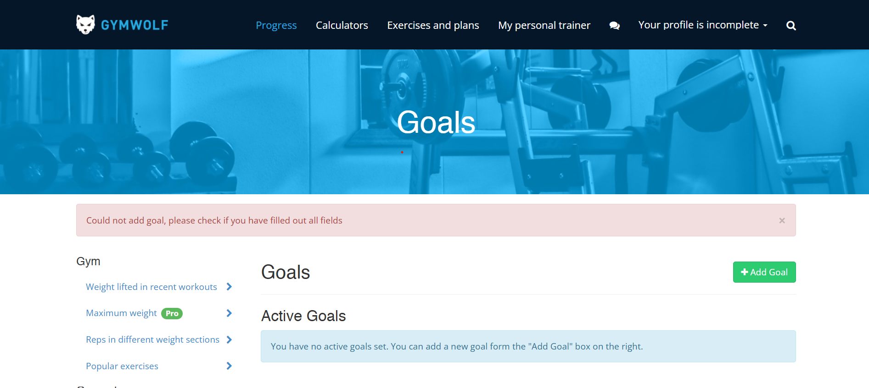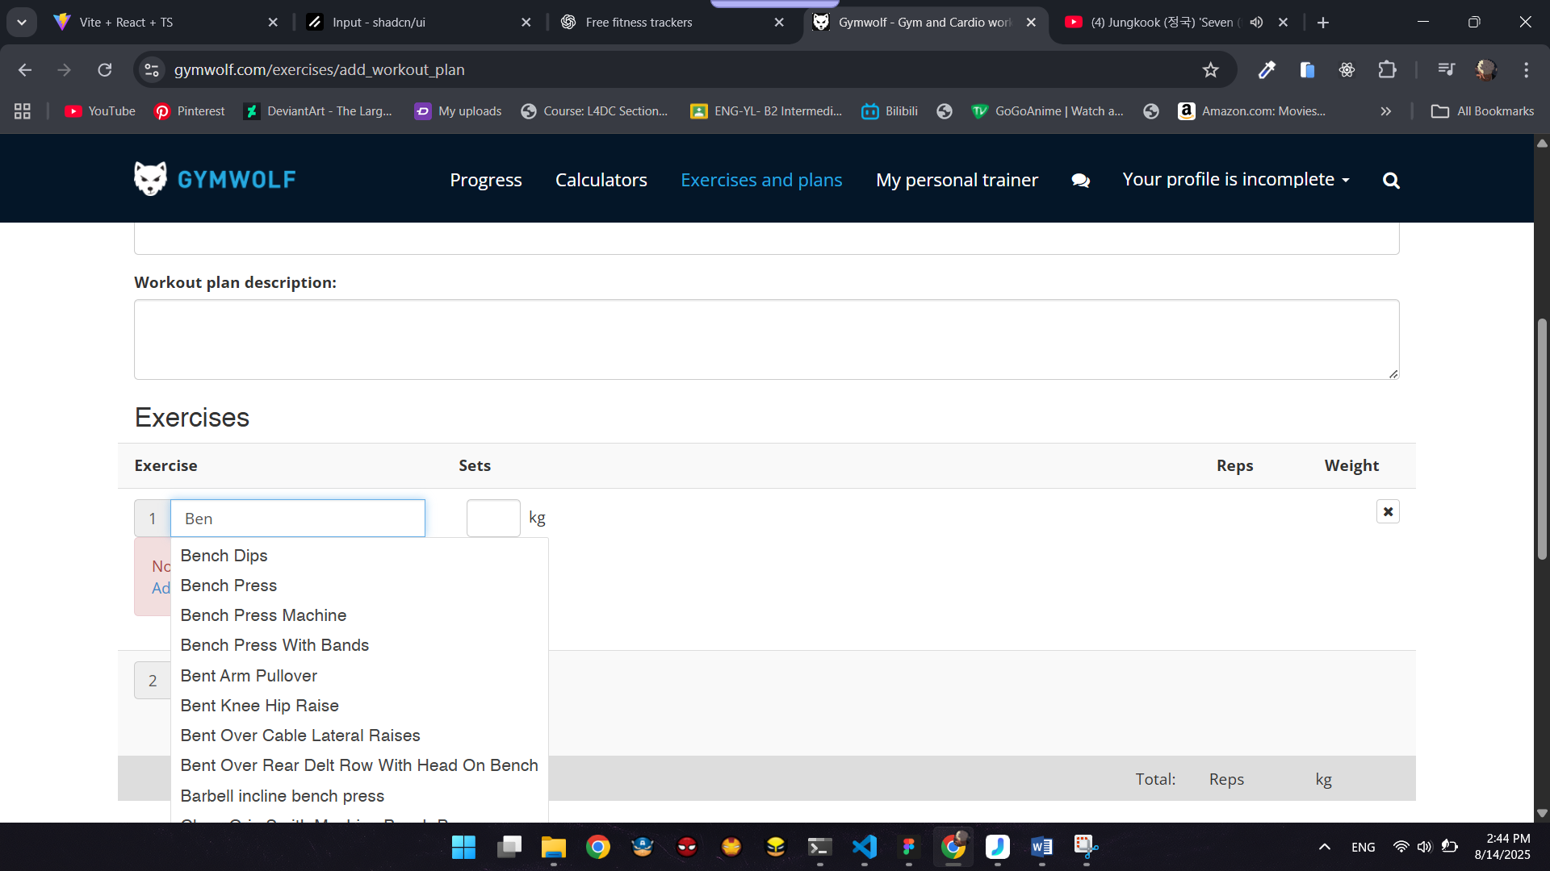

In the GymWolf website, the system response with exact error message so that users know that which part do they need to fix. For example, in the first image, user does not input the goal and click the add button, therefore, the system returns the error message that, the goal has to be set. Moreover, when users add workouts in the routine plan, the existing workout collapse and user do not have to manually type in, which reduces that error prevention.

Recognition rather than recall

As the images provided in other section, it can be seen that in the GymWolf website, there are details description about each workout and routines and related images so that users can recognize easily. Studies have also shown that images-based systems are more recognizable rather than text-based ones. Moreover,

#### Flexibility and efficiency of use



It is very flexiblie to use for the members. For instance, users can create new workout plan other than the standardized plans. Also in creating the new plan, users can choose the workouts not only from the existing library but also create a new workout so that user can add their favoured workouts to their personal routine plans. This is very efficient and flexible for both beginners and advanced users.

#### Aesthetic and minimalist design

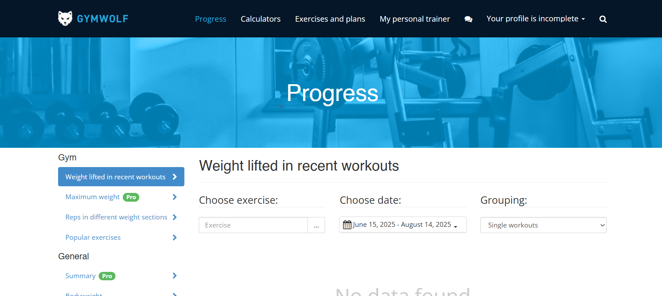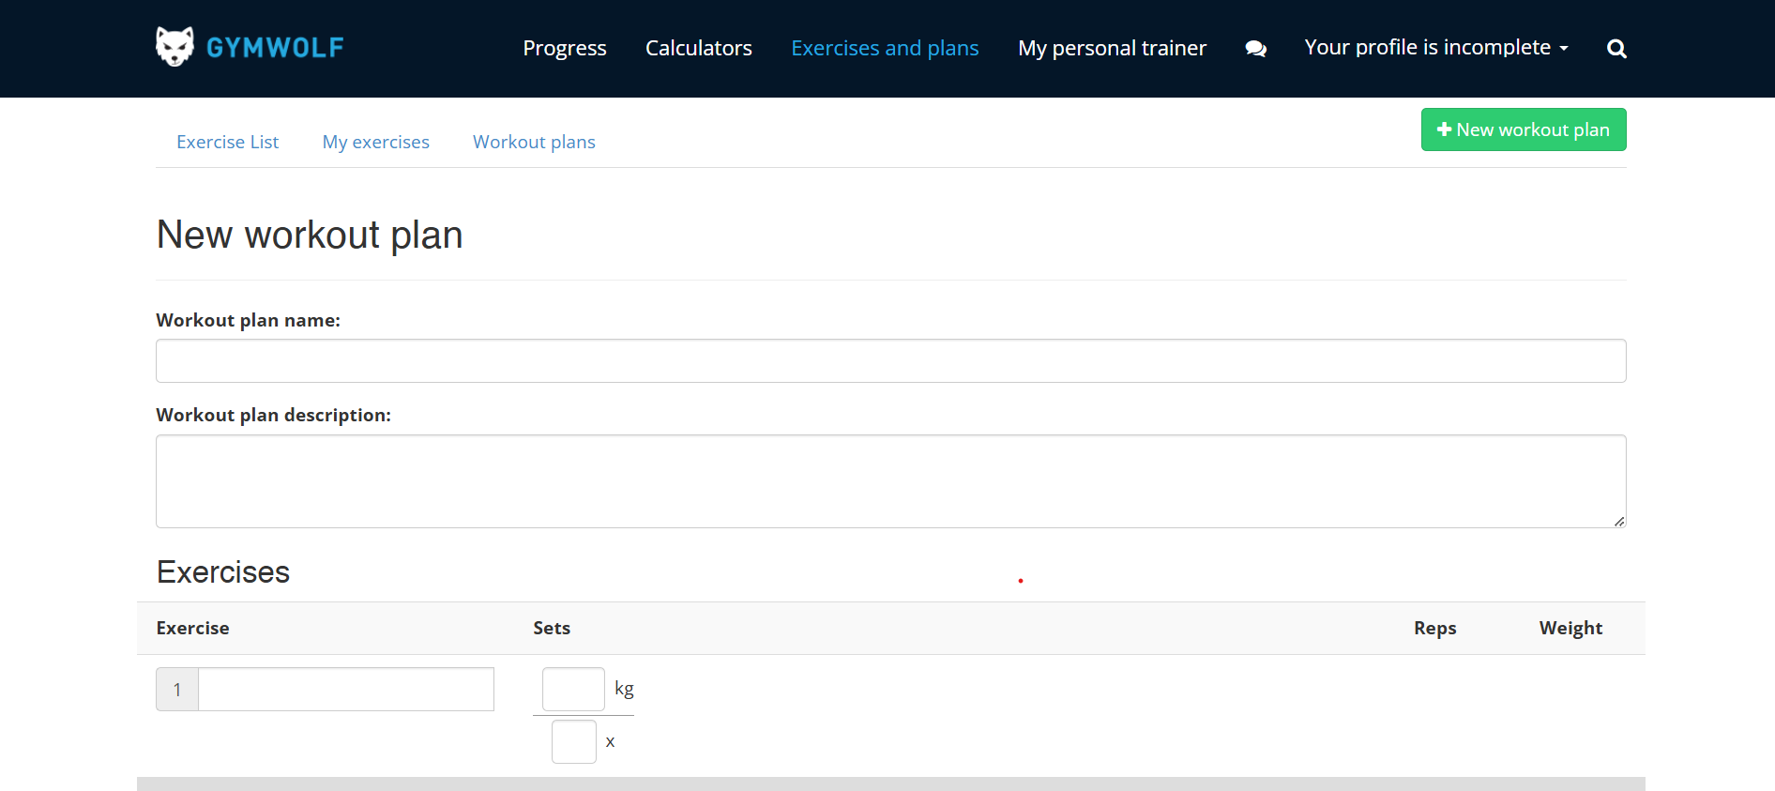

This GymWolf also uses light blue as the highlight color and white and black colors as default background and foreground color. The layout and designs are also simple and minimal so that users can easily use the website. Even though, it is not aesthetic as Hevy, this web app is more minimal and user friendly.

#### Help and documentation

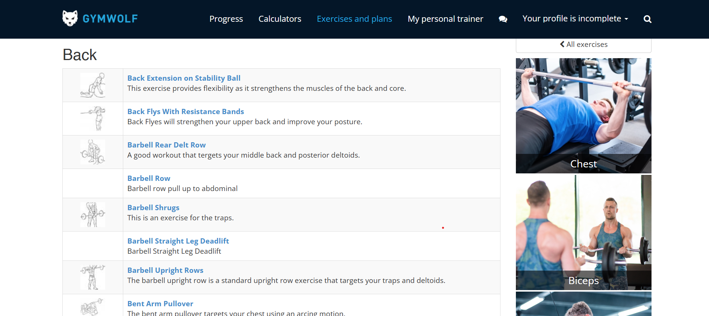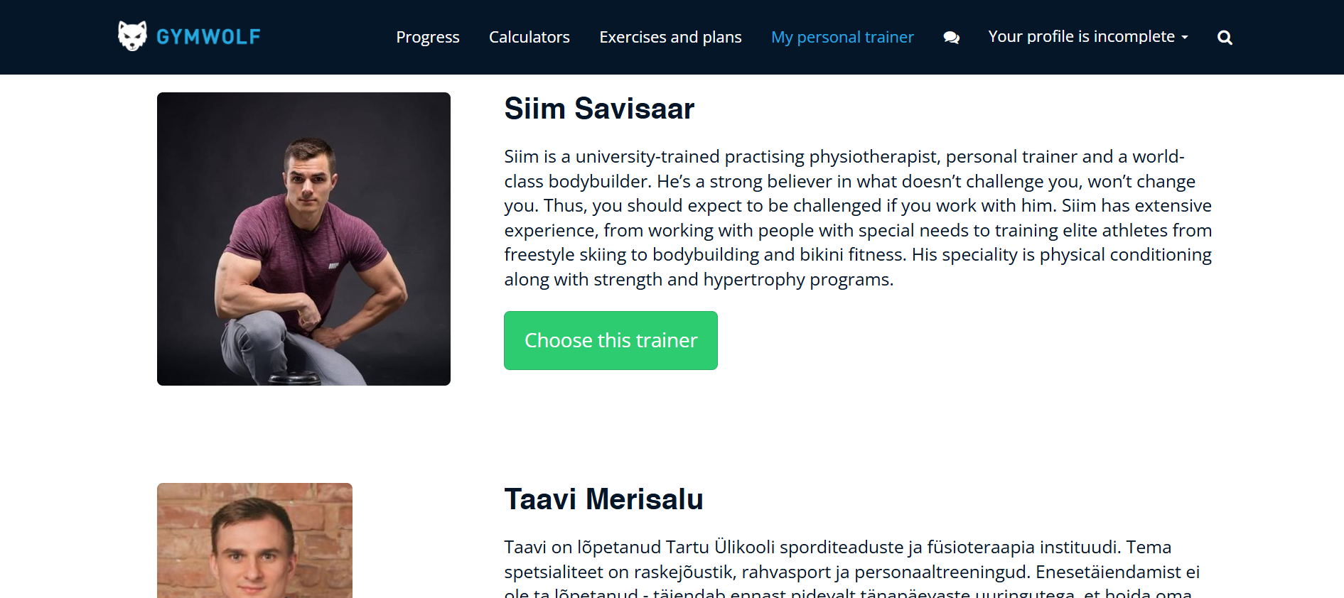

The website includes detailed documentation to help guide through the system. For example, there is description and image about each workout under each title. This can help the users how to perform each workout Moreover, in the trainer section, there are description about each trainer so that users can read about them and can choose the whoever trainer they want.

### Hevy

#### Visibility of system status

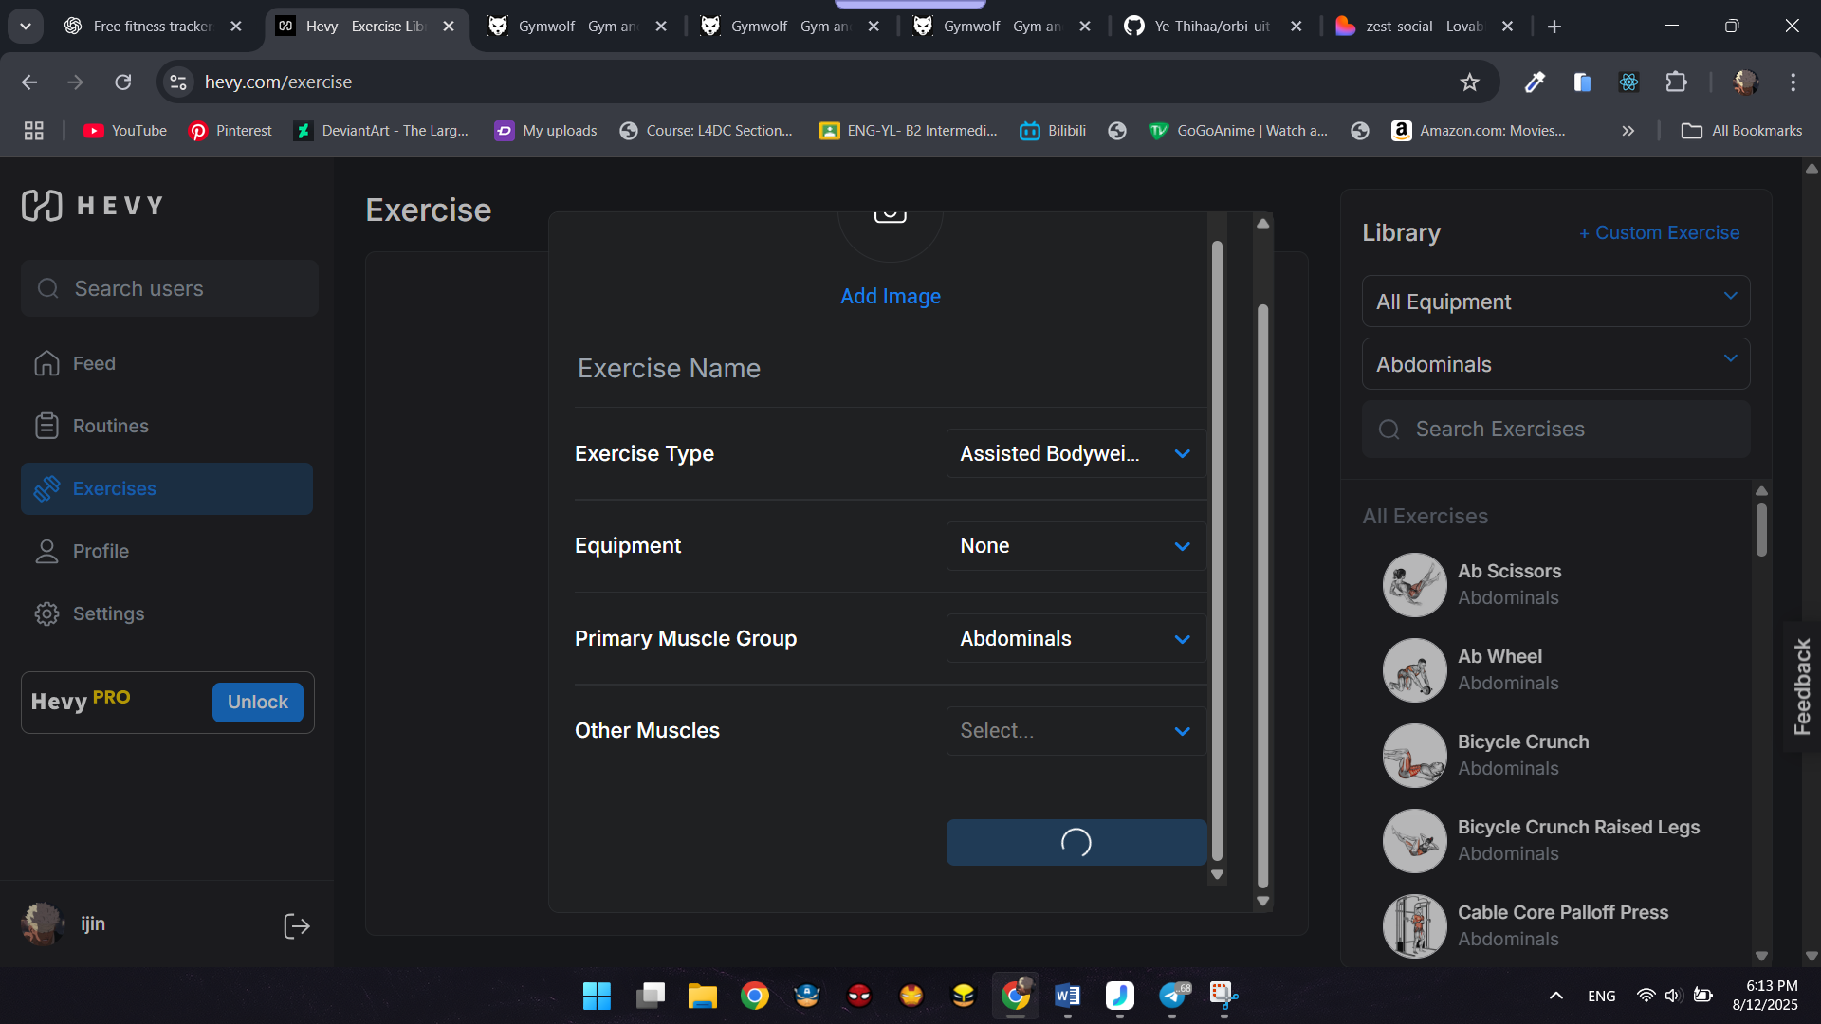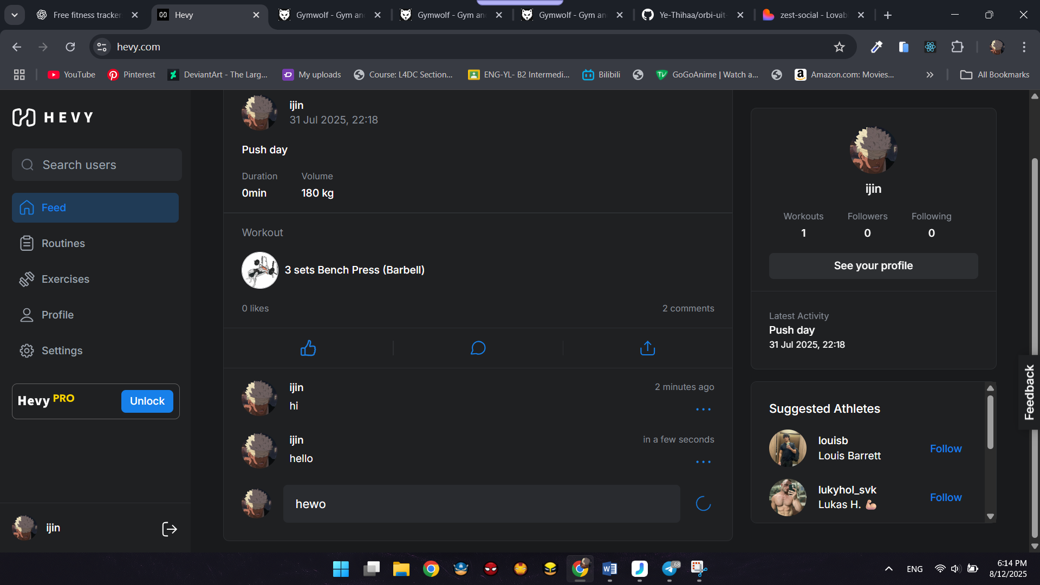

In the system, the system makes sure to let the users know what the system in doing. For example, when creating the new workout and clicks on the create button, it changes into loading state. It shows the user that the system is creating new one. Also, in commenting, when the user click on post button, it changes into loading state before posting it.

#### Match between system and the real world

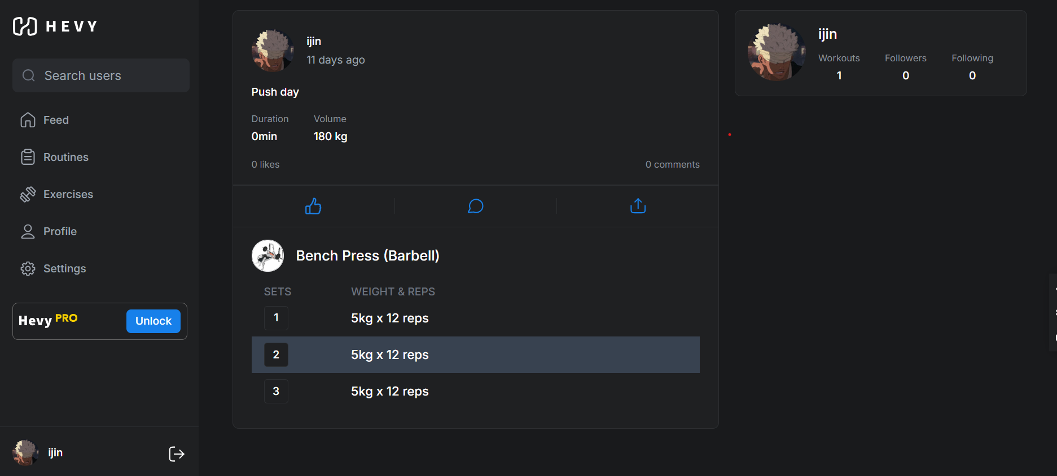

The workouts include sets and reps which aligns with the real-world fitness system. Besides, users can set the weights every time user workout so that users can avoid manual tracking system but can apply computerized tracking methods.

#### User control and freedom

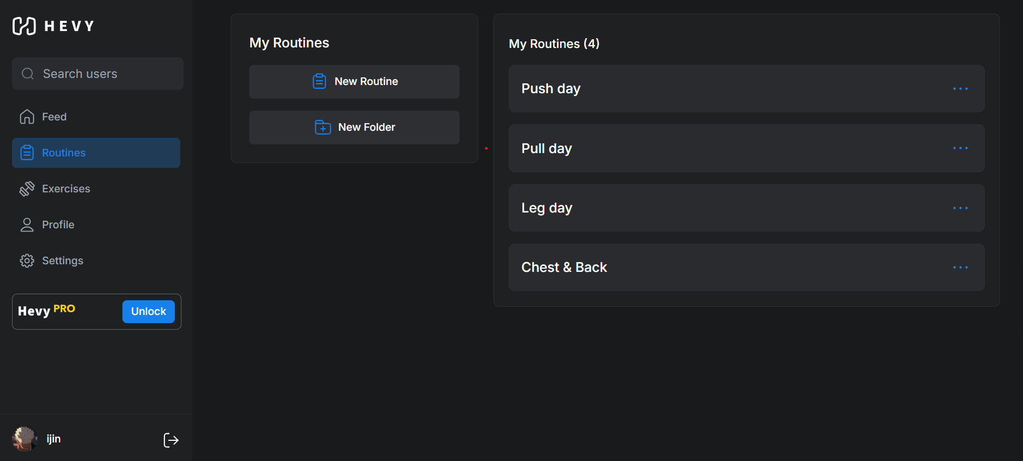 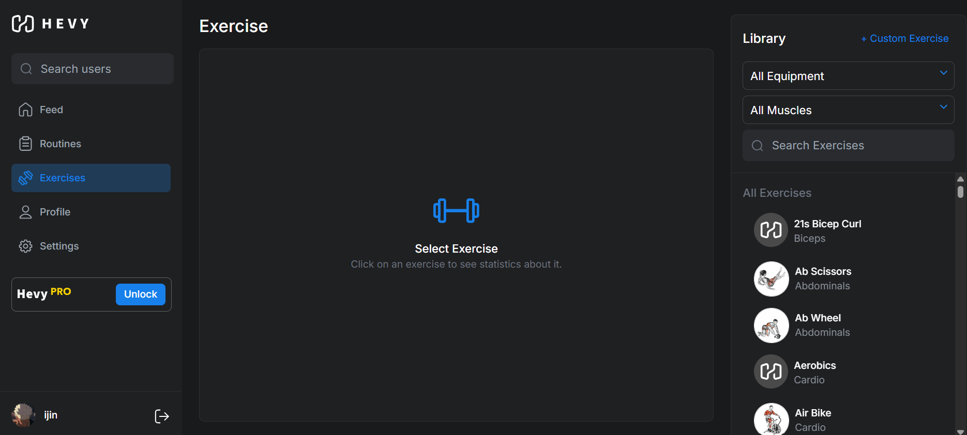

Users have free control over the system. For example, they can not only create the new workouts any limitation but also create new routines that can align with their body. Moreover, user can also edit their profile information as they please.

#### Help users recognize, diagnose and recover from errors

According to the images I have provided above, users can easily recognize what to do when entering the website. The system includes recognizable buttons with related icons so that users know if they want to add a workout log, they should click on workout log button. The system also shows the exact error message which mean users recognize the error and fix the error next time. For example, in the password update page, when the user enters wrong password, the system shows the exact error message so that user know they have typed in the incorrect old password.

#### Error Prevention

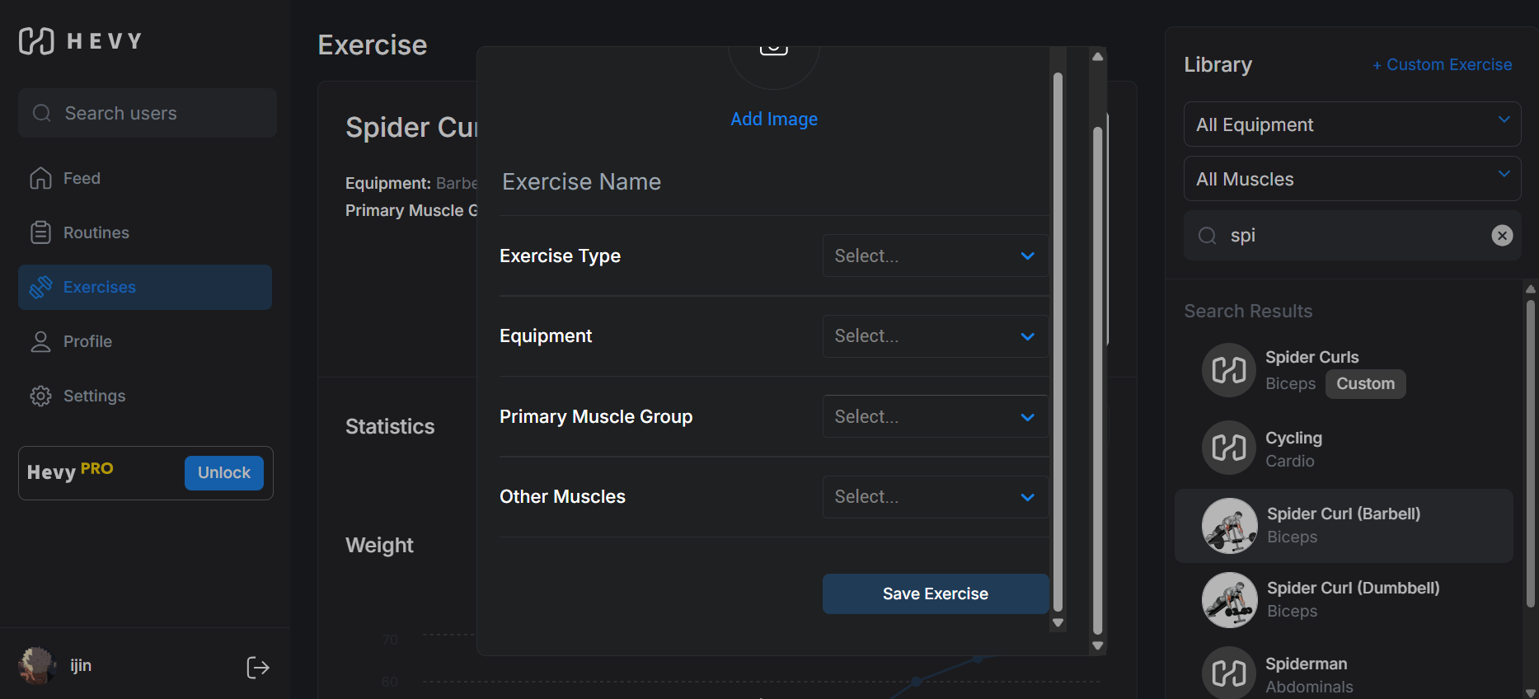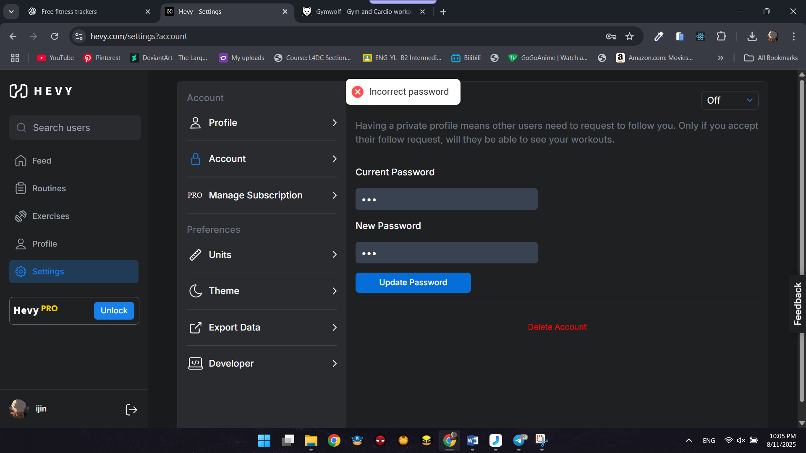

The system does not allow the user to input incorrect data and if any incorrect data is typed, the system responses with detailed error message. For example, in the updated password page, when the user input the incorrect old password, the system shows that “Incorrect Password”, that lets user know that, he is typing the wrong password. Also, in creating the new workouts and routines, the system does not allow the user to create new unless the required data are chosen. This can prevent the further errors.

#### Recognition rather than recall

Hevy has the unique template, layouts user interface and logo. Therefore, users can recognize they are using the Hevy fitness tracking system. Besides, they can also recognize not only by the system’s color and UI designs but also by the system’s unique functions such as tailored workouts and routines and graph-based statistics.

#### Flexibility and efficiency of use

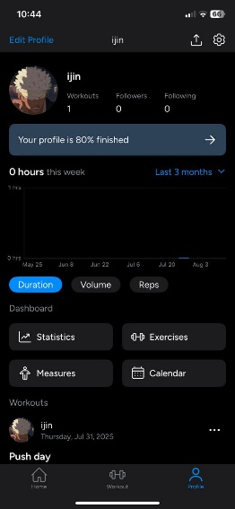

Since the software provides the user creation functions, it is extremely flexible for the members who want the tailored routine plans that are specifically aligns with their weak points in their bodies. Moreover, the system can be used both in web and mobile, so that users can use the software when they are outside which is very convenience to use.

#### Aesthetic and minimalist design

As shown in the images provided above, consistent color combination. They use blue color as their highlight color so that it aesthetically aligns with both light mode and dark mode. The designs and layouts across the pages are also the UI designs are consistent in the website. Moreover, there are no extra designs and minimal so that users do not confuse about the design patterns.

#### Help and documentation

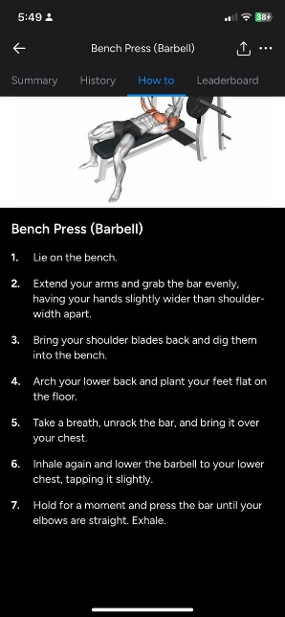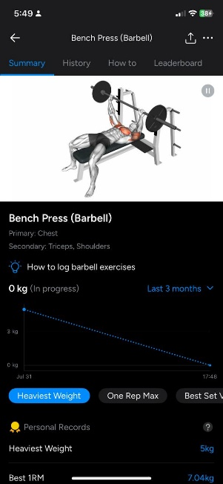

The system provides description about each workout so that the users can follows each step to complete the routines. Besides, there is also a video of each workout so that if the user does not understand with the text description, they can follow up with the video. This feature can guide the user to achieve their goals.

## Usability based on performance

### GymWolf

#### Effective to use

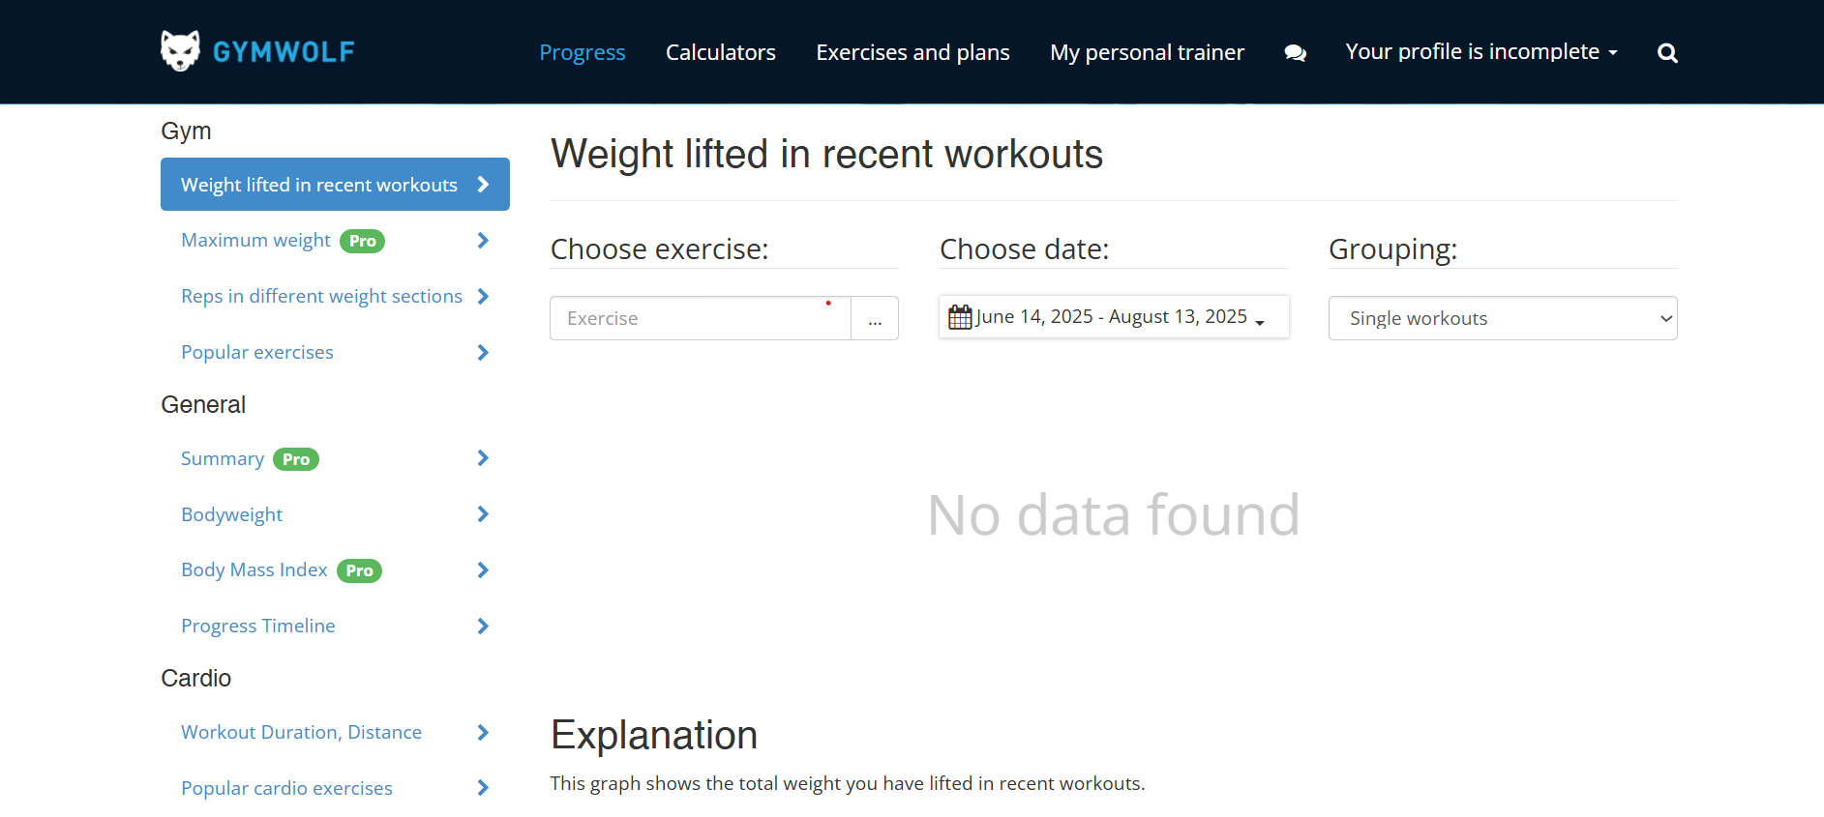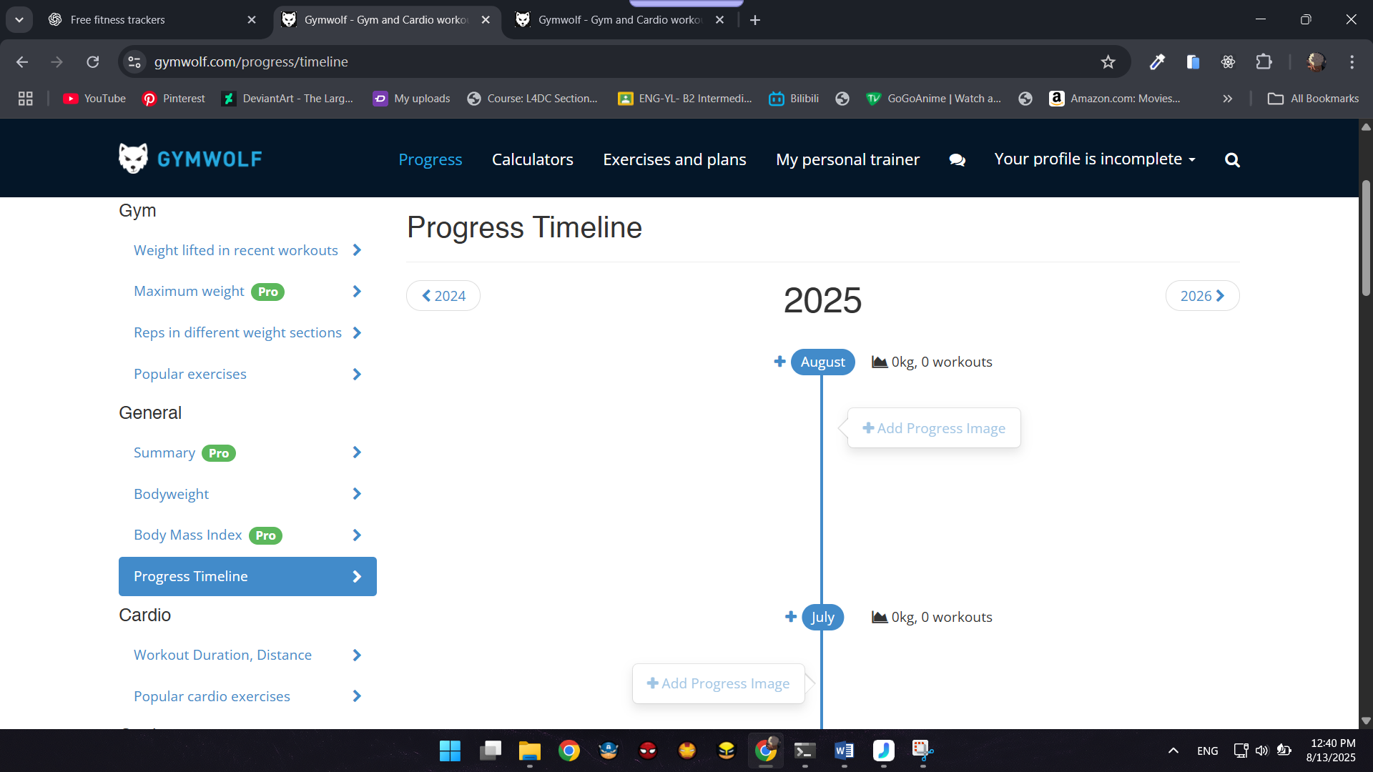

GymWolf also supports workout logging features, progress tracking features which is essential in fitness tracking system. Moreover, users can view the progress timeline with a visual appearance. This is very effective to fitness users.

#### Efficient to use

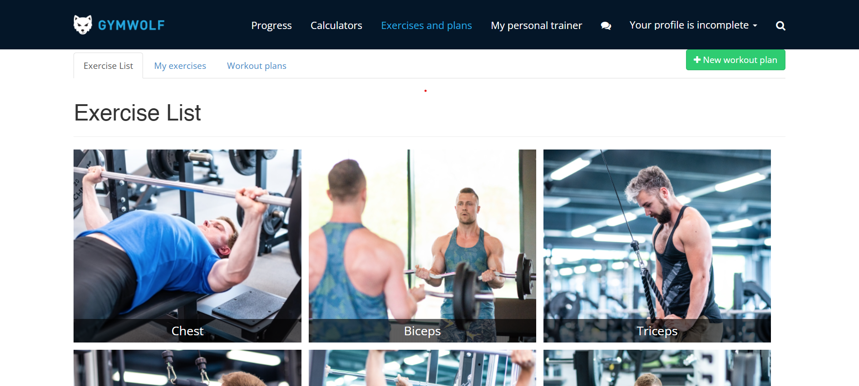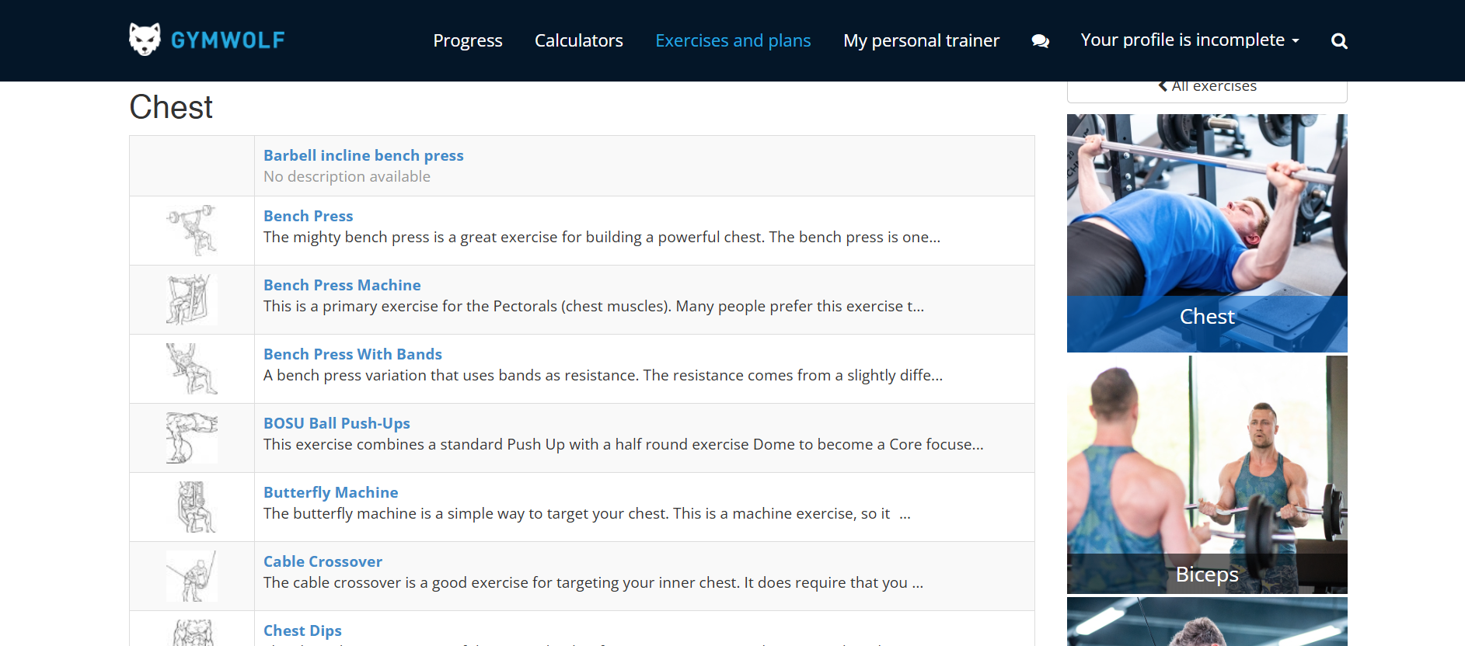

GymWolf is also very efficient to use since it includes an exercise library. Member can easily access the workouts that are available. Moreover, in each muscle group, there are various exercise list that can be done. It is very efficient for both members and trainers.

#### Safe to use



It is also safe to use; the system also has error prevention features. For example, in the above image, I clicked on the add goal button and a form appears but I did not input anything and click on add button. After that, the error message shows that the goal could not be added. It shows that the system is safe to use, not accepting fraud or null errors.

#### Have good utility

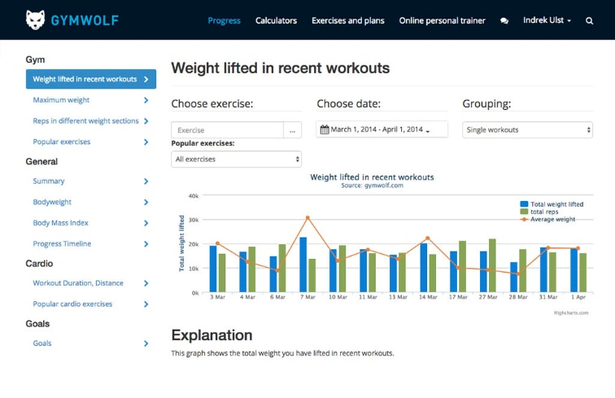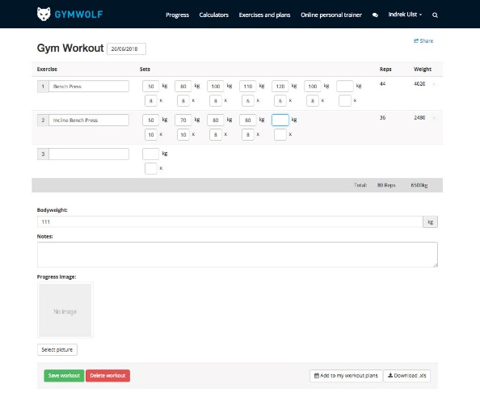

Being a fitness tracking website, it includes details functional features, such as progress tracking with graph-based system. It shows that total weight lifted with date and time. Besides, users can also log each workout so that the members can easily make records of their progress.

#### Easy to learn

As in the images I have provided above, the website is easy to learn not only for advanced users but also for amateurs. For example, throughout the website, there is consistent navigation bar so that the users can easily navigate through pages. Besides, the buttons and layouts are also user-friendly and makes it easier for the first-time users.

#### Easy to remember how to use

Since the website uses consistent layout designs and color combinations throughout the pages so that users remember every time they use GymWolf fitness tracking system. Its unique workout creation and progress tracking features also make the users easily recognize the website.

### Hevy

#### Effective to use

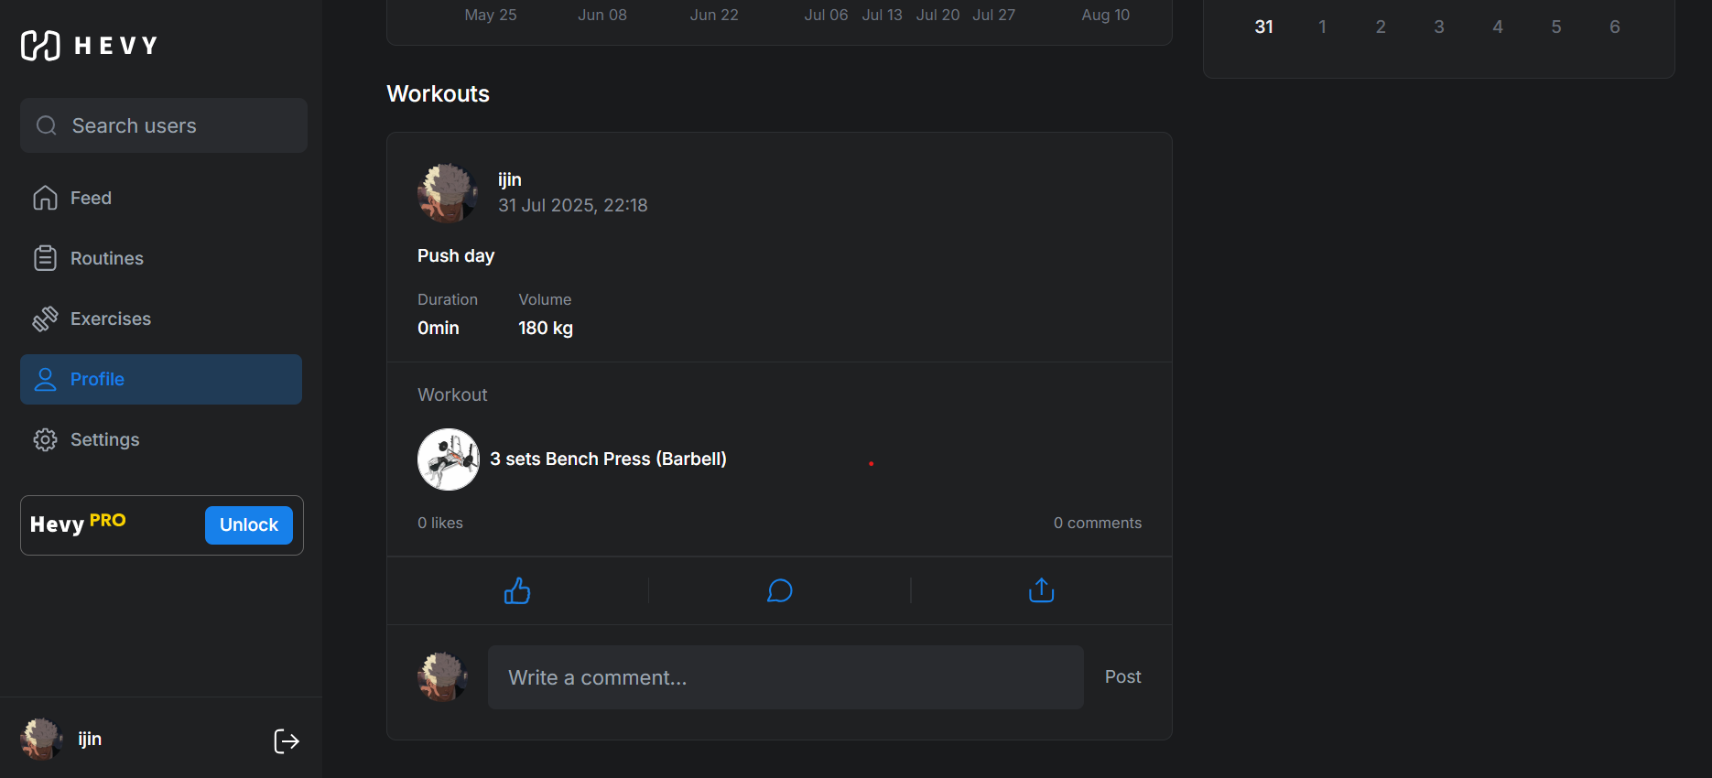

In the profile section, it shows that what workouts and routines has completed with the exact date and time. It is extremely effective so that the users can keep track of their workouts and can see their performance during the workout.

#### Efficient to use

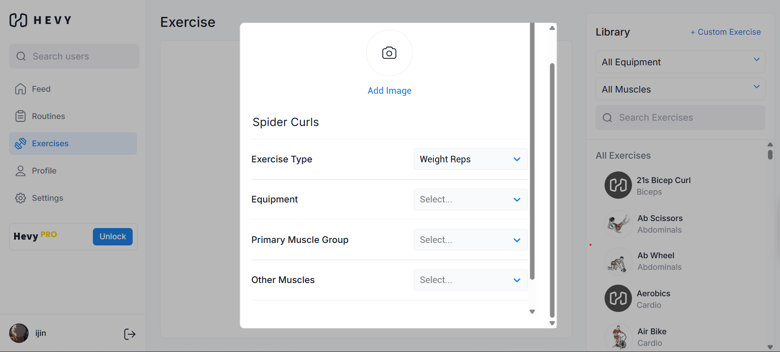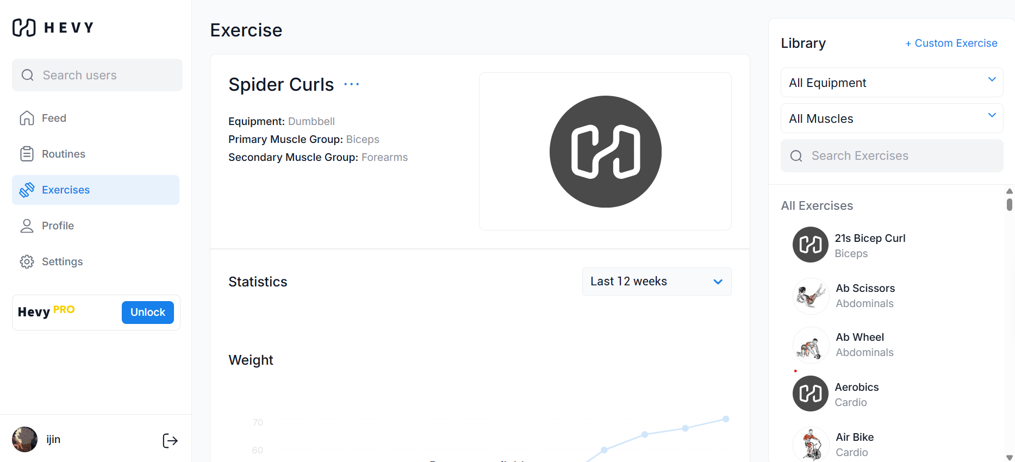

The users can create new workouts within a short amount of time easily if they want new type of workouts in their library. Even though, it will be strange to new members but it will be a very efficient function to experienced members who are using the software. Even after creating, the user can see the details about the newly created ones.

#### Safe to use



Also, in creating the workout, users cannot create new workouts without entering the required data so that users cannot create fraud data. They have to input all of the required to make a complete workout which results in safety. Also, in second image, when the user input the incorrect data, the system response with the error message. For example, I type in the wrong current password and click in the update password which results in responding the Incorrect Password error message.

#### Have good utility

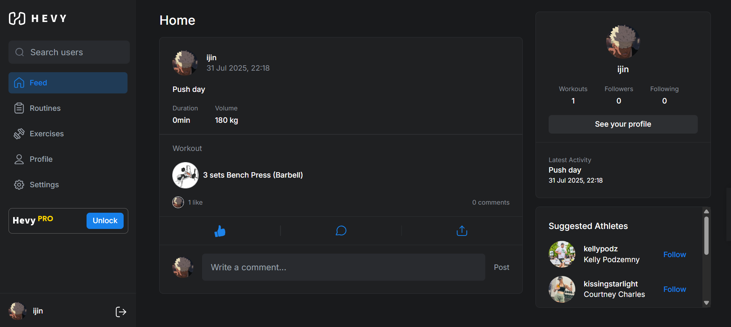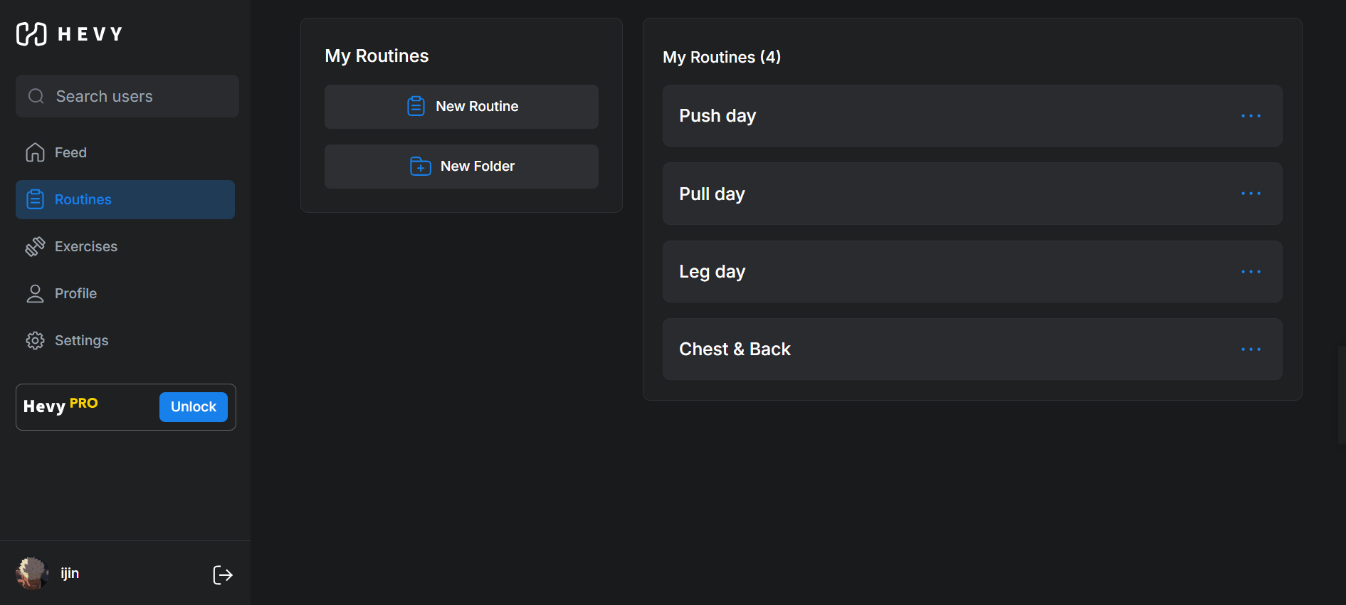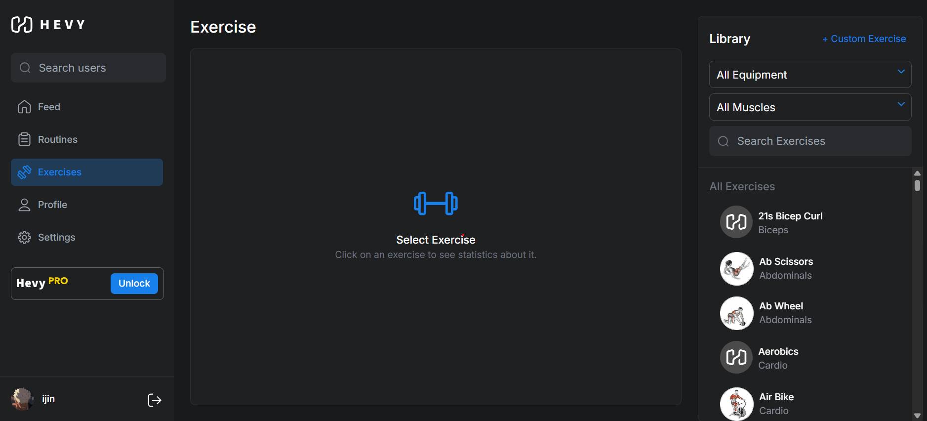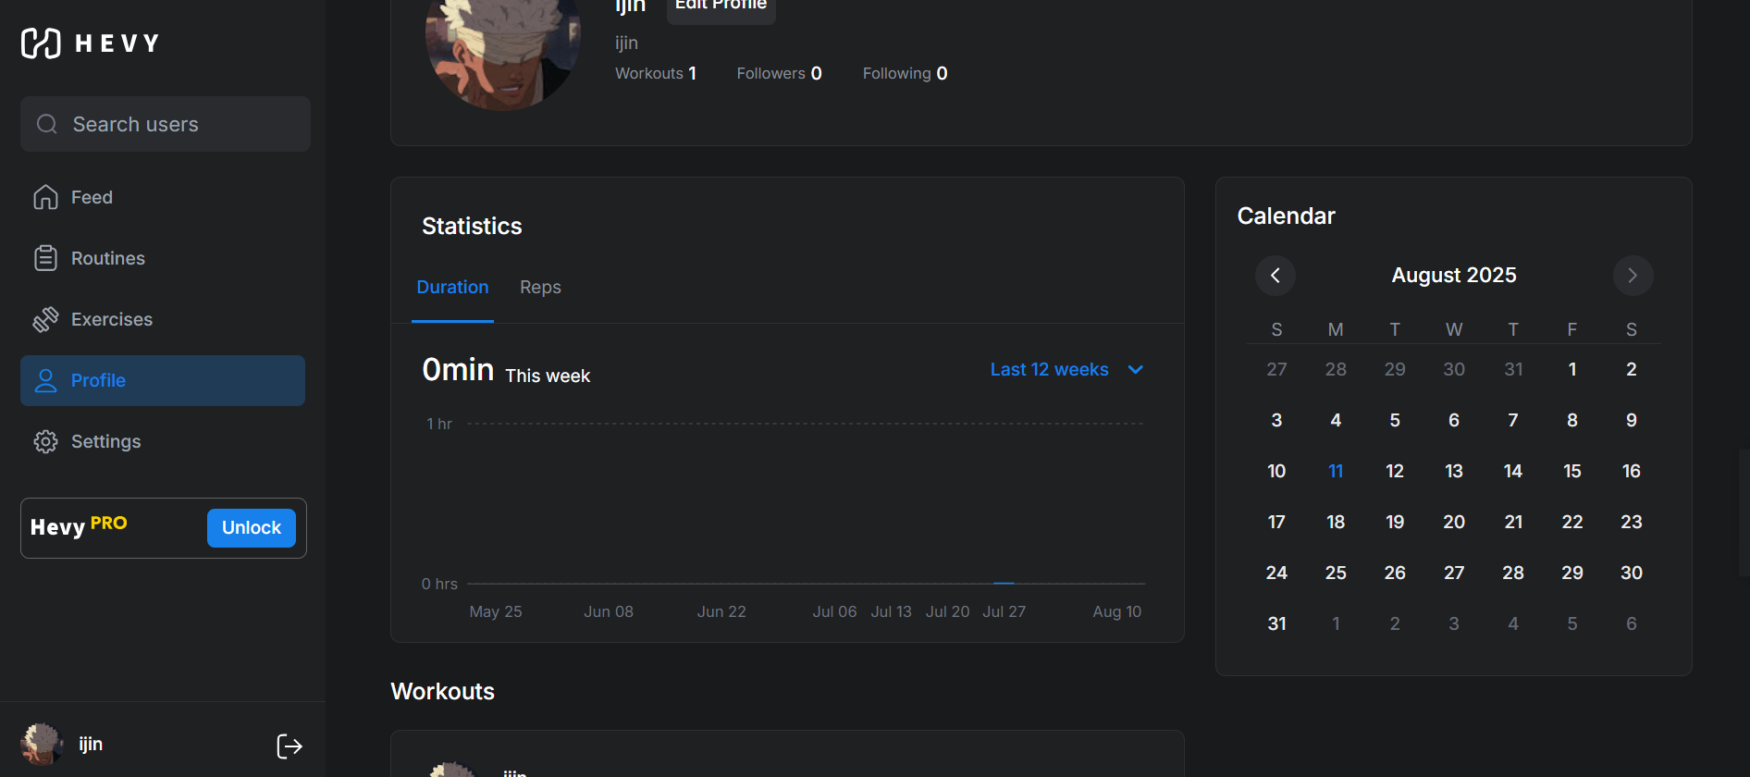

Hevy has well organized features that can be called to have good utility. For example, Hevy has community features which can connect with other online fitness members. Secondly, the system allows users to create tailored routines and workouts. This is an advanced feature for the fitness tracking system because in the world of fitness, all of the people are not the same, some may have weak arms and some might have weak legs. Therefore, users might want to create tailored routines that might help with their weakness. Lastly, there are statics section which tracks the user progress in the profile section, which can help the members out with their tracking process.

#### Easy to learn

According to the images that are provided above, it can be clearly seen that the user interface of Hevy is simple and minimal. The UI can be easily understood and the users can easily adapt and learn about the website. Most of the elements includes icon in order to be visually appeal and aesthetic.

#### Easy to remember how to use

Hevy has consistent pages and UI designs throughout the website. The sidebar helps the users to find out in which page they are currently in and guide through pages. Moreover, the structure of the system is familiar to most of the fitness system and can be easily learnt. For example, in real life, the personal trainer gives the customized routines to their clients. The system implements the same logic that the users can create new routines and workouts. Therefore, the users can easily remember how to use the system whenever they enter the website.

# Legal, Social, Ethical and Professional Issues and Considerations

## Legal

**Data privacy** can be considered as the one of the legal issues. Data privacy law in Myanmar does not as large impact as in other countries. This can lead to unauthorized access and the confidential data of users can be breached by attackers. Besides, there are no legal policies in collecting or sharing the users’ data. One of the solutions to prevent data privacy is to implement the **GDPR** (General Data Protection Regulation) in the system. This can potentially reduce the risk of data being breached by outsiders (EU, 2025). Second solution is that system should provide the options to customize the user’s data as the users please so that they can delete their data later on.

Another issue is caused by the **cyberattacks**. Since, Myanmar has low data privacy and protection, scammers and cyberattacks are targeting the systems that can be attacked effortlessly. They can break the system by using attacks such as SQL injection, brute-force login attempts or placing malware inside the system (gov.je, 2025). This kind of attack can be prevented by applying **OWASP** securities policies such as implementing two-factor authentication, updating software patches regularly so that they can detect the new malwares, undergoing pen testing to exploit weak spots in the system and using cryptography measures such as using HTTPS instead of HTTP (OWASP, 2025)

## Social

The first social issue might be **accessibility**. In Myanmar, there are not only the urban cities which can easily access the internet but also the rural areas where there is no internet access or limited electricity. The solution to this to **degrade the system to low-bandwidth**. Another solution is to design a mobile software so that users can easily access with their mobile phones.

Another issue is the **internet** **issue**. Even thought there is internet access in rural sites, the connection is unstable. This can lead to inconsistent real-time data or saved data will be lost. To solve this, the system should include **offline mode**. For example, in this fitness tracking system, the system should allow the users to download the routines file so that they can access offline.

## Ethical

**Collecting** user’s personal data such as body measurements and **sharing** them within the organization without the user’s permission can violate the user’s autonomy and it is clearly unethical. This can cause loss of user’s trust. There can also be consequences of being sued legally if the user gets to know that their data is being sold out. This can be prevented by implementing **OECD** Privacy Gridlines (OECD, 2025).

Another issue is that there can be **trust issues**. For example, users can be prevented by registering the websites that require personal information, fitness tracking system, for instance. Therefore, without legal actions or policies, users may feel scammed. This can lead to loss of potential customers and the system’s reputation can be damaged. To solve this, the w ebsite should be partnered with certain organizations that are officially recognized. The system should display official certificated in order to trust users’ trust.

## Professional

Lately, many fitness industries are emerging and getting recognized. In this kind of world, it is becoming more and more **competitive** to break through this industry. This can lead to gaining less profits and market shares. This can be solved by applying **Porter’s Five Forces** which first scans the threat of the rival organizations and emphasizes on unique advantages in order to keep the customers (Gratton, 2025). Moreover, the system should offer **value-based services** so that users can gain something useful to them.

Another issue is **user training and support**. Some of the users might have used fitness software beforehand but some may not have any experience with this type of system. The user interface should be user-friendly so that user can easily utilize the software without any guidance. Besides, if the interface is complicated, there should be guidelines or step-by-step tutorials. This can reduce the usability and negative reviews from the users. Moreover, the team should implement **OTIL** (Information Technology Infrastructure Library) into the system to aid in user training and support (AXELOS, 2025)

# Requirements

## Analysis of requirements

Before developing the CoreFitness system, it is crucial to understand the requirements that the system should have and the expectation of the users. Therefore, identifying the requirements can lead to emphasize the important features and structure of the system.

The purpose of the CoreFitness system is to convert the current manual fitness system to computerized online fitness tracking system where users have to registered through the system in order to access the workouts and routines that are created by admin and trainers. Moreover, other sub purpose is to track the user’s progress within the system so that the members can see their progress throughout their journey.

Besides, users’ needs are also identified and analyzed so that users can get the gist of the system. Users want user-friendly and easy-to-use system so that they can easily adapt to the system. Besides, with the aim of having the user’s freedom, the system allows the users to create their favorite tailored routine.

Also, in performance needs, they system should have responsive designs so that the users can access with their mobile phones through browsers. The performance should be good enough to handle multiple users and have quick loading.

Moreover, they system should also have security needs, protecting the user data, encrypting the login credentials, for instance. Since it is a role-based system, it should be checked when logging in so that each role can access their authority in their related web pages.

The system should be flexible and scalable so that users can add new workouts and routines without occurring any critical errors.

## Targeted Users

The CoreFitness is created for the users who are enthusiastic and want to committed in fitness activities. The targeted users can certainly benefit multiple features from this website such as personal fitness monitoring and routine creation. The first targeted users are gym members. They are the people who want to refined their health through computerized system. There can be both amateurs who are new to fitness and advanced level members who have fitness knowledge. They directly interact with website performing certain actions such as registering, viewing the workouts and creating routines, tracking the progress. Another key user are trainers, they nearly have the same authority as the system admin. They can create both workouts and routines. Each trainer can have one or more than assigned members. They have the access to manage the members. Lastly, system administrators have the full authority to the whole system and can see each trainer and member details.

To sum up, the system targets the users who wants to start their fitness journey including from beginners to advanced users. People who don’t want any limitations about the routine creation can also try out the system. People who want to monitor their fitness activities, not by tracking manually but tracking with system, can also use the system. Lastly, people who are busy with their life can use this system since it can help members remotely so that people do have to go to gym and meet up with their personal trainers.

## Explanation of Use Case diagrams

### Use Case 1: User Registration and Authentication

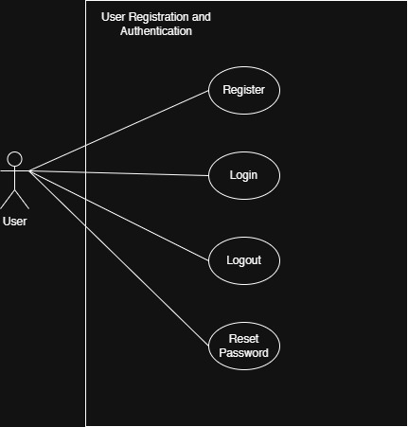

New users have to register first before accessing into the system. Those who already have accounts can login into the system with their email and password. After logging in, each user will be directed to their respective dashboards based on their roles. They can also logout after the use and can reset the password if they forgot the password.

### Use Case 2: User Management

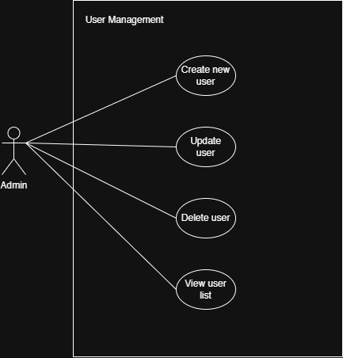

Admin can manipulate the existing users. New users can be created either by registration of the user himself or admin can create the new user. They can also update the user information and delete the existing users. Moreover, they can view the list of the users, including both trainers and members.

### Use Case 3: Personal Trainer Assignment

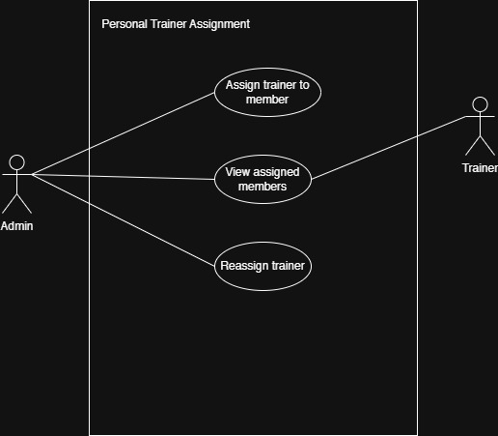

Admin can assign the personal trainer to the members if the member requests. Both the admin and trainer can view the assigned members. Moreover, admin can also reassign the trainers if the user requests.

Use Case 4: Progress Tracking

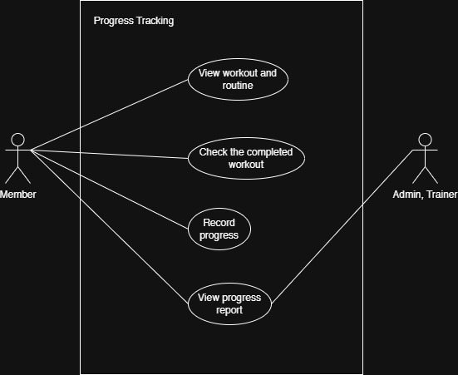

During working out, users can tick off the done workout or routines which will be taken as the data for the progress. After that those progress is recorded and results as the progress report which can be viewed by members, admin and trainer so that users can be motivated watching back their progresses.

## Arrangements of Functional requirements

### Time Box 1 – User Registration and Authentication

Functional Requirements:

1. User Registration – New users have to register into the system in order to access the system features.
2. User Login – If the user already has the account, they can login into the system using email and password.
3. User Logout – Users can logout after the using the system.
4. Password Management – Users can reset their password if they forget the old one.
5. Input Validation – The input fields should be validated in order to avoid fraud data input.
6. Email Verification – Users can create account or login into the account using their emails.
7. Role-based Access – When logging into the system, users do not have to select the role, based of the email address, they can log in according to their roles.

### Time Box 2 – User Management

Functional Requirements:

1. View all Users – Admin can view all of the users in the system.
2. Create Users – Users can be created both by user registering himself or admin creating a new one.
3. Update User Information – Admin can update the details of each users and the users can update their information.
4. Delete User – Admin can delete the users in the system.
5. Search and Filter Users – Admin can search a certain user by using filters such as name or emails.
6. View User Details – Admin can view the detail information of each user.
7. Deactivate User – Admin can deactivate the users who are inactive for a long time.

### Time Box 3 – Personal Trainer Assignment

Functional Requirements:

1. Assign Trainer – Admin can assign personal trainer to the users.
2. View Assigned Trainer – Admin and trainer can view the personal trainer who is assigned to respective member.
3. Reassign Trainer – Admin can reassign the personal trainer if the user request.

### Time Box 4 – Progress Tracking

Functional Requirements:

1. View Workout and Routine – All of the users can view the workouts and routines
2. Mark the Completed Workout – Member can tick off the completed exercises during working out.
3. Record Progress – The system will record the data after the user ticked off the exercise.
4. View Progress – The users can view their progress analytic report.
5. Edit Progress Entry - The system will allow the user to edit or update the entry of the progress.
6. Achievement Tracking – The user will be notifying if they reach the certain milestones.

## MoSCoW Prioritization of the process

### Time Box 1 – User Registration and Authentication

Must Have

* User Registration
* User Login
* User Logout

Should Have

* Password Management
* Input Validation
* Role-based Access

Could Have

* Email Verification

### Time Box 2 – User Management

Must Have

* View all Users
* Create new Users
* Update Users
* Delete Users

Should Have

* Search and Filter Users
* View User Details

Could Have

* Deactivate User

### Time Box 3 – Personal Trainer Assignment

Must Have

* Assign Trainer
* View Assigned Trainer

Should Have

* Reassign Trainer

### Time Box 4 – Progress Tracking

Must Have

* View Workout and Routine
* Mark Completed Workout
* Record Progress
* View Progress

Should Have

* Edit Progress Entry

Could Have

* Achievement Tracking

## Arrangements of Non-functional requirements

|  |  |  |
| --- | --- | --- |
| No. | Non-functional Requirements | Description |
| 1. | Performance | The system response should be fast in order to improve the user experience. Log in and registration process should not take too long. When users log in, it should only take about 2 seconds. The data should also be loaded immediately after landing on the page for the user satisfaction. |
| 2. | Scalability | The system should be able to handle the number of users that will increase in the future. |
| 3. | Security | The system should have authorized the users with secure and strong password. Based on the login information, the system should redirect to the respective dashboard. |
| 4. | Availability & Reliability | The system should be available at any time so that members can access the website whenever they want to work out. Main functions such as user registration, workout library and progress tracking should be reliable with the least downtime without any errors. |
| 5. | Usability | The system should have user-friendly interface for all of the users, not only for members but also for trainers and admin panels. Errors messages should be clearly shown so that the users can get what they are wrong and how to fix the errors. |
| 6. | Maintainability | The system should be easy to update and maintain, for example, new workouts and routines can be added to the library and can certain roles can delete the routines. |
| 7. | Compatibility | The system not only work in different browsers such as chrome, Firefox and safari, but also can be able to run smoothly with desktop, phone and tablets. |
| 8. | Data Integrity | The system should ensure that all of the user’s important information should be kept securely. For instance, saving the hashed passwords within the system. |

# Design and Timebox Planning

## Conceptual and Detailed Class Diagram (Overall System)

### Class Diagram

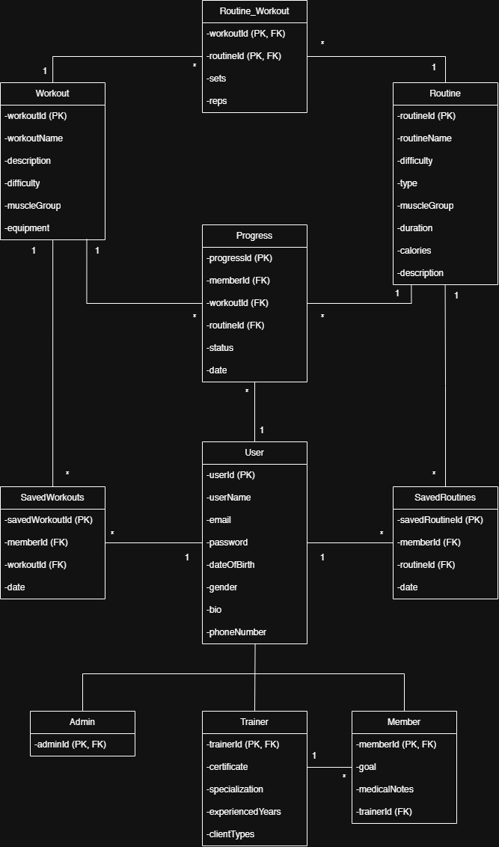

## Explanation of Conceptual Diagram & Class Diagram

### Class Diagram

#### User

This is the main user class that include the general information of a user such as name, password, date of birth, gender, bio, phone number and unique attributes such as userId and email.

#### Admin

Admin class is the sub class of the user class who will take control of the overall system such as system administrator or gym manager.

#### Trainer

Another sub class of user class is trainer class which will include detailed information about the trainer, certificate, specialization, experienced years and client types. This class also has relationship to member class.

#### Member

Member class is also the sub class of user class who are the main end user of the system. This class contains the other detailed data such as goal, medical notes and information about the assigned personal trainer which is connected by the trainerId.

#### Workout

This class is workout class which will detain the information of each workout in the database which will be viewed by the users.

#### Routine

Routine class also has the same concept as the workout class which stores the details of the routine class that will be accessed by the users.

#### Routine_Workout

This is the dummy table which connects the routine class and workout class. For example, in a single routine, there will be many workouts, each consists of numbers of sets and reps.

#### Progress

The purpose of progress class is to record the workout journey of the user so that member can view their progress and be motivated.

#### SavedWorkouts & SavedRoutines

These classes are for the users to store the workouts and routines in their profile.

#### Overall Explanation

There will be three types of users in the system. The first one is admin, who has the highest role in the system. They have all access in the system where they can manipulate the users, workouts and routines. Secondly, trainers are also the users who can manipulate workouts and routines. Then, members are the main end users of this system who will be using this system as the fitness tracker. Members can save their favorite workouts and routines in their database and they can view their progress throughout their workout journey.

## Low-level screen design prototype

## High-level screen design prototype

## Timebox for User Registration and Authentication

|  |  |  |  |  |
| --- | --- | --- | --- | --- |
| **Timebox Name** | Timebox (1) User Registration and Authentication | | | |
| **Description** | The purpose of this timebox is to create a secure user authentication and registration. | | | |
| **Start Date** | 12 December 2024 | | | |
| **End Date** | 26 December 2024 | | | |
| **Target Users** | System Administrator, Gym Manager, Member, Trainer | | | |
| **No.** | **Task** | **Duration** | **Start Date** | **End Date** |
| 1. | Plan for Timebox (1) | 1 | 12 Dec 2024 | 12 Dec 2024 |
| 2. | Functional Requirements | 1 | 13 Dec 2024 | 13 Dec 2024 |
| 3. | Use Case Diagram | 1 | 14 Dec 2024 | 14 Dec 2024 |
| 4. | Class Diagram | 1 | 15 Dec 2024 | 15 Dec 2024 |
| 5. | Screen Design (Low-level Prototype) | 5 | 16 Dec 2024 | 20 Dec 2024 |
| 6. | Screen Design (High-level Prototype) | 5 | 21 Dec 2024 | 25 Dec 2024 |

## Timebox for User Management

|  |  |  |  |  |
| --- | --- | --- | --- | --- |
| **Timebox Name** | Timebox (2) User management | | | |
| **Description** | This timebox focuses on manipulating the users of the system. | | | |
| **Start Date** | 2 January 2025 | | | |
| **End Date** | 16 January 2025 | | | |
| **Target Users** | System Administrator, Gym manager | | | |
| **No.** | **Task** | **Duration** | **Start Date** | **End Date** |
| 1. | Plan for Timebox (1) | 1 | 2 Jan 2025 | 2 Jan 2025 |
| 2. | Functional Requirements | 1 | 3 Jan 2025 | 3 Jan 2025 |
| 3. | Use Case Diagram | 1 | 4 Jan 2025 | 4 Jan 2025 |
| 4. | Class Diagram | 1 | 5 Jan 2025 | 5 Jan 2025 |
| 5. | Screen Design (Low-level Prototype) | 5 | 6 Jan 2025 | 10 Jan 2025 |
| 6. | Screen Design (High-level Prototype) | 5 | 11 Jan 2025 | 15 Jan 2025 |

## Timebox for Personal Trainer Assignment

|  |  |  |  |  |
| --- | --- | --- | --- | --- |
| **Timebox Name** | Timebox (3) | | | |
| **Description** | This timebox emphasizes the function of assigning personal trainer to the users. | | | |
| **Start Date** | 1 Feb 2025 | | | |
| **End Date** | 14 Feb 2025 | | | |
| **Target Users** | System Administrator, Gym Manager, Trainer | | | |
| **No.** | **Task** | **Duration (day)** | **Start Date** | **End Date** |
| 1. | Plan for Timebox (1) | 1 | 1 Feb 2025 | 1 Feb 2025 |
| 2. | Functional Requirements | 1 | 2 Feb 2025 | 2 Feb 2025 |
| 3. | Use Case Diagram | 1 | 3 Feb 2025 | 3 Feb 2025 |
| 4. | Class Diagram | 1 | 4 Feb 2025 | 4 Feb 2025 |
| 5. | Screen Design (Low-level Prototype) | 5 | 5 Feb 2025 | 9 Feb 2025 |
| 6. | Screen Design (High-level Prototype) | 5 | 10 Feb 2025 | 14 Feb 2025 |

## Timebox for Progress Tracking

|  |  |  |  |  |
| --- | --- | --- | --- | --- |
| **Timebox Name** | Timebox (2) Progress Tracking | | | |
| **Description** | The aim of this timebox is to track the progress of each user and generate a analytic report of these progresses. | | | |
| **Start Date** | 2 March 2025 | | | |
| **End Date** | 16 March 2025 | | | |
| **Target Users** | System Administrator, Gym Manager, Member, Trainer | | | |
| **No.** | **Task** | **Duration** | **Start Date** | **End Date** |
| 1. | Plan for Timebox (1) | 1 | 2 Mar 2025 | 2 Mar 2025 |
| 2. | Functional Requirements | 1 | 3 Mar 2025 | 3 Mar 2025 |
| 3. | Use Case Diagram | 1 | 4 Mar 2025 | 4 Mar 2025 |
| 4. | Class Diagram | 1 | 5 Mar 2025 | 5 Mar 2025 |
| 5. | Screen Design (Low-level Prototype) | 5 | 6 Mar 2025 | 10 Mar 2025 |
| 6. | Screen Design (High-level Prototype) | 5 | 11 Mar 2025 | 15 Mar 2025 |

# Development, Testing & Evaluation

Unit test – CRUD validate

Integration test – feature g 1 khu lone a lok lok ma lok

Evaluation – kyone kae tk a kht a kel

# Bibliography

# Appendices